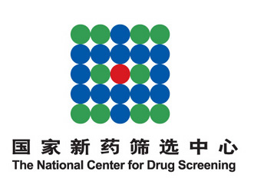

2016 Queenstown Molecular Biology Meetings in Shanghai
⎯ Drug discovery and translational medicine

Young Investigators’ Forum
After successfully launching the 1st Queenstown Molecular Biology (Shanghai) Meetings in March 2013, we repeated that experience in 2014 and 2015 which received a tremendous responses among both domestic and overseas scientific community. As a result, the Queenstown Molecular Biology Meetings Society of New Zealand and the National Center for Drug Screening will hold 2016 Queenstown Molecular Biology (Shanghai) Meetings between March 17 and 18, 2016. The event will focus on the theme of “Drug discovery and translational medicine” and be concurrent with the 8th National Forum on New Technologies in Drug Discovery and the 5th Meeting of Chinese Network for Drugs and Diagnostics Innovation (http://en.cncl.org.cn/2681/55149/134540.shtml).
Queenstown Molecular Biology (QMB) Meetings were initiated in New Zealand about 25 years ago as an annual gathering of bioscientists in New Zealand and Australia. This event, has become a well-known international science forum over the years and is held during the last week of August each year. We have started a spring version of this conference in Shanghai as part of Sino-New Zealand collaboration.
Young Investigators’ Forum as one of several satellite sessions will be organized as a key part of the curriculum, providing a platform for academic exchanges among young scientists engaged in drug discovery.
- Young investigators should hold a position of assistant professor or above (or equivalent titles in an industrial setting).
- A 15-minute oral presentation should be made in English.
- The deadline for abstract submission is February 20th, 2016 (by e-mail).
- Once accepted, the speakers will be waived for registration fee.
- Contact persons: Professor Yi Zang (yzang@simm.ac.cn)
Dr. Yueting Chen (ytchen@simm.ac.cn)

2016 Queenstown Molecular Biology Meetings in Shanghai
Young Investigators’ Forum
Family name |  | Sex
Given name |  | Nationality
Organization
Job title/position |  | Fax
Telephone |  | Cell phone
E-mail |  | Postcode
Postal address
Talk title
Abstract

